Scott Chamberlain
Module 7.2 Assignment
CSD325-T301 Advanced Python

4a.
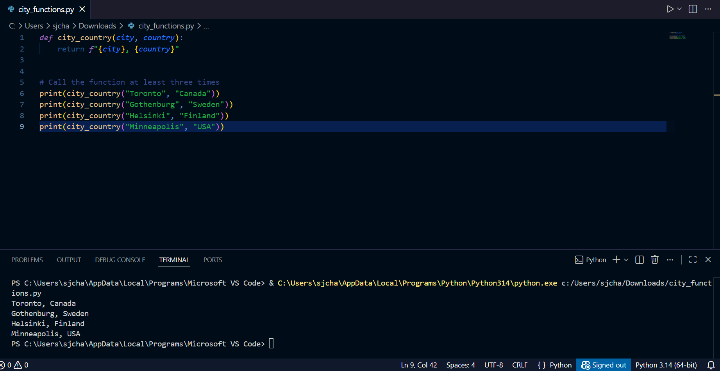

4b.
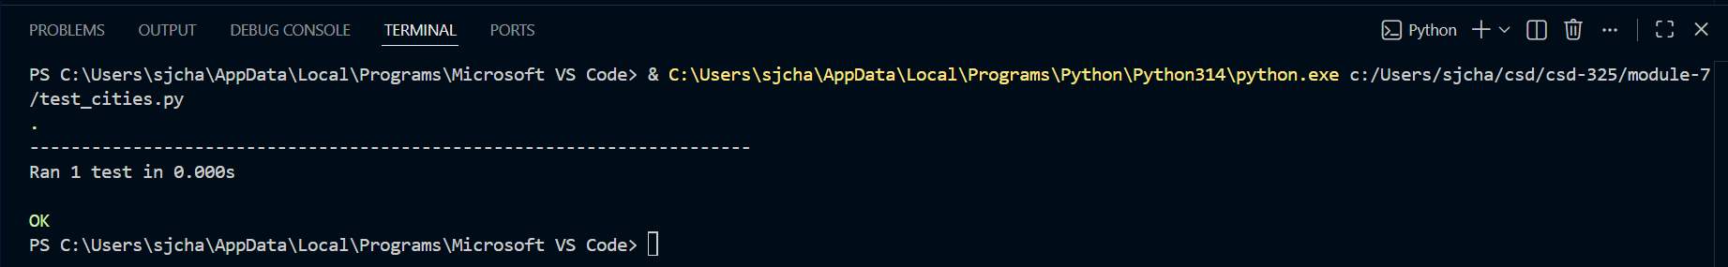

4d.
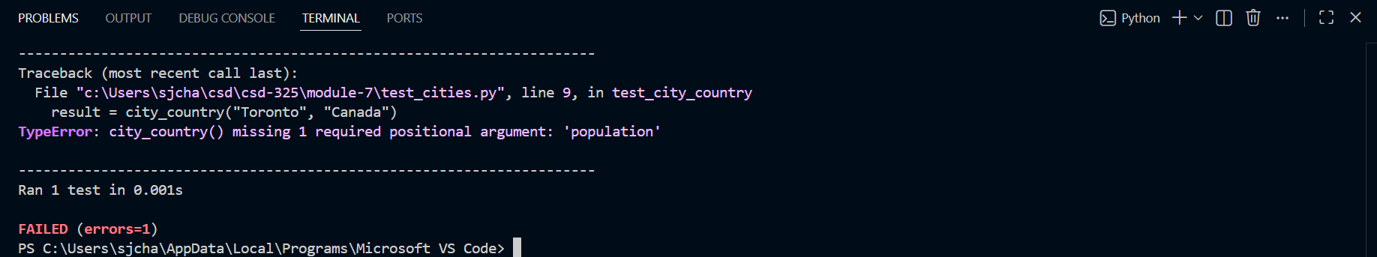

4f.
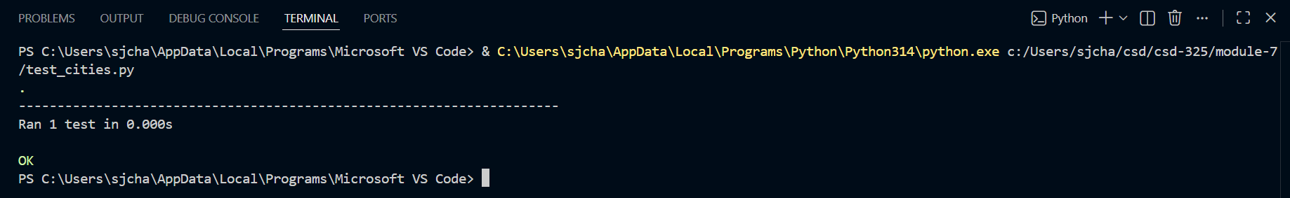

4h.
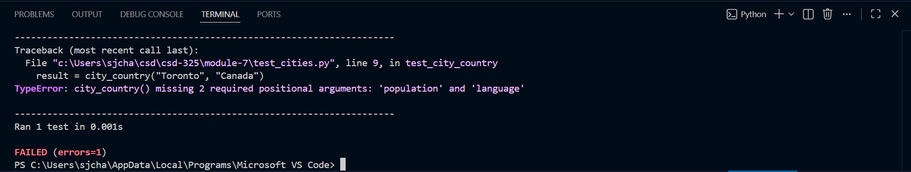

4j.
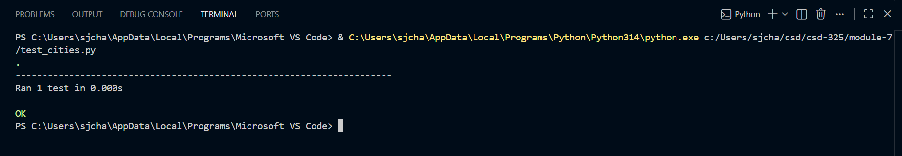

4k.
